### 2**. Creating a Serverless API**

**Objective**: Develop a serverless API using AWS Lambda and API Gateway.

**Approach**:

* **Define API**: Design a simple RESTful API (e.g., for a todo list application).
* **Lambda Functions**: Create Lambda functions for each API method (GET, POST, PUT, DELETE).
* **API Gateway Setup**: Use API Gateway to set up the API endpoints, connecting each endpoint to the corresponding Lambda function.
* **Testing**: Test the API using tools like Postman or AWS API Gateway test functionality.

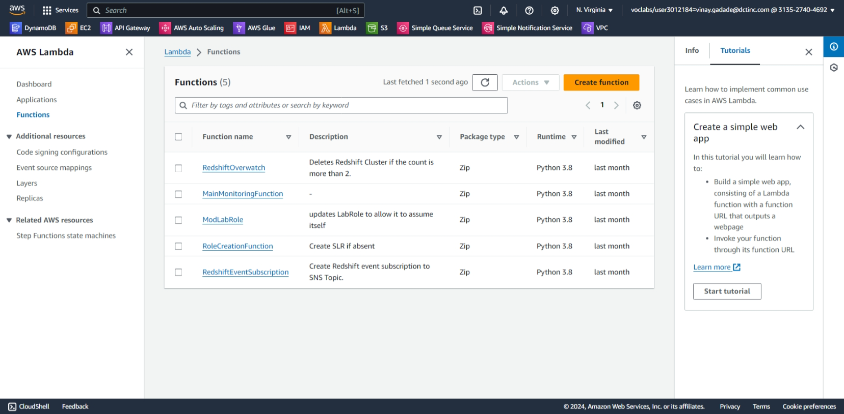

**Create 4 fuctions with name get ,put ,delete ,post with permission use and existing role {“lab-role”}**

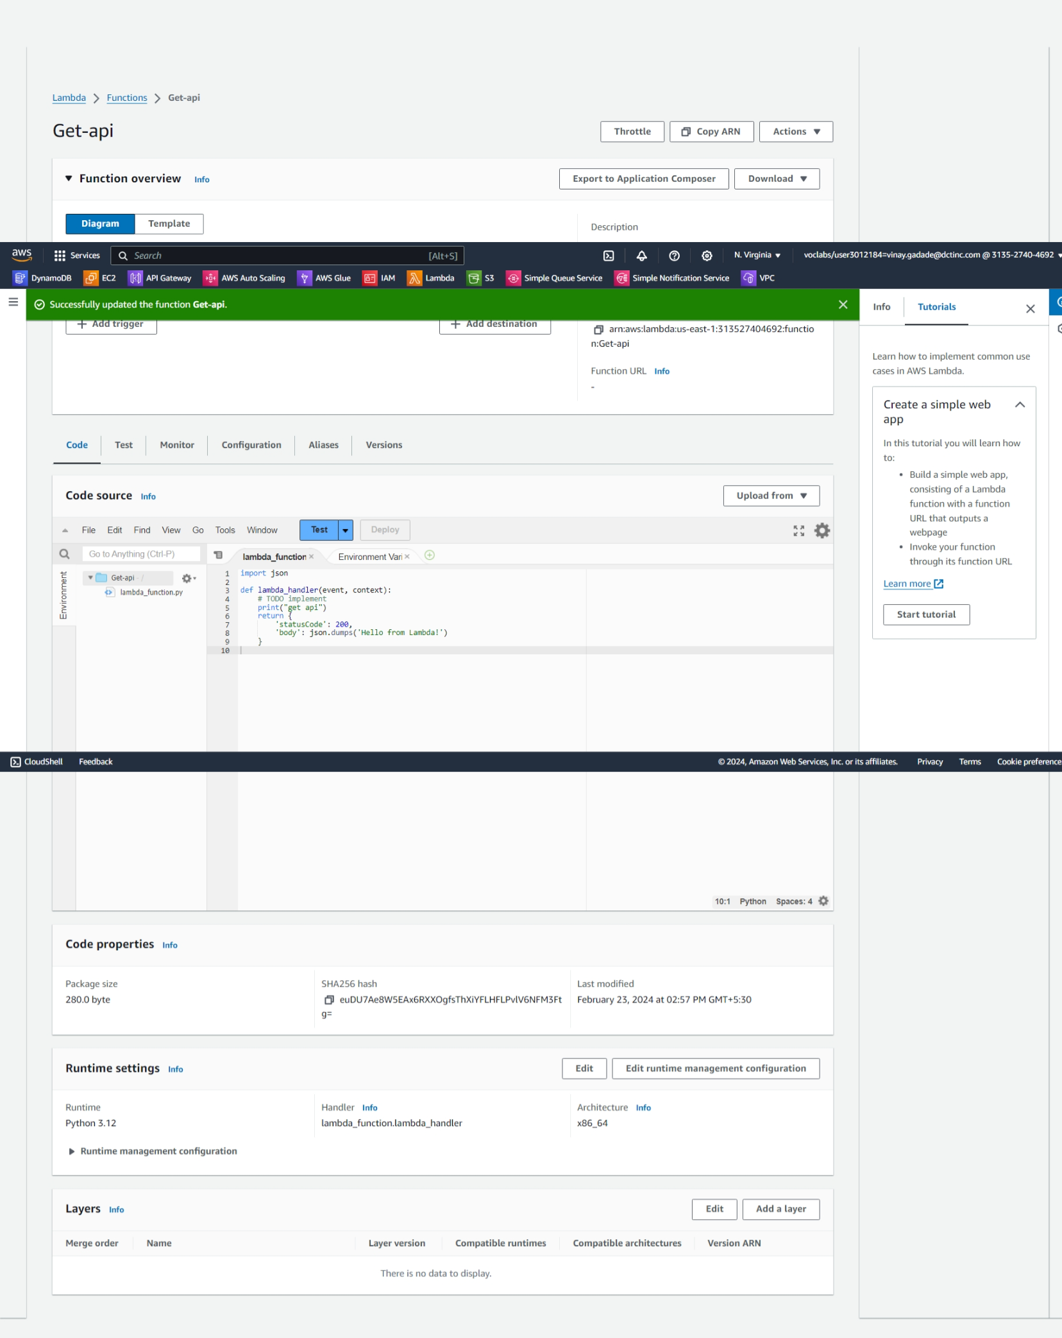

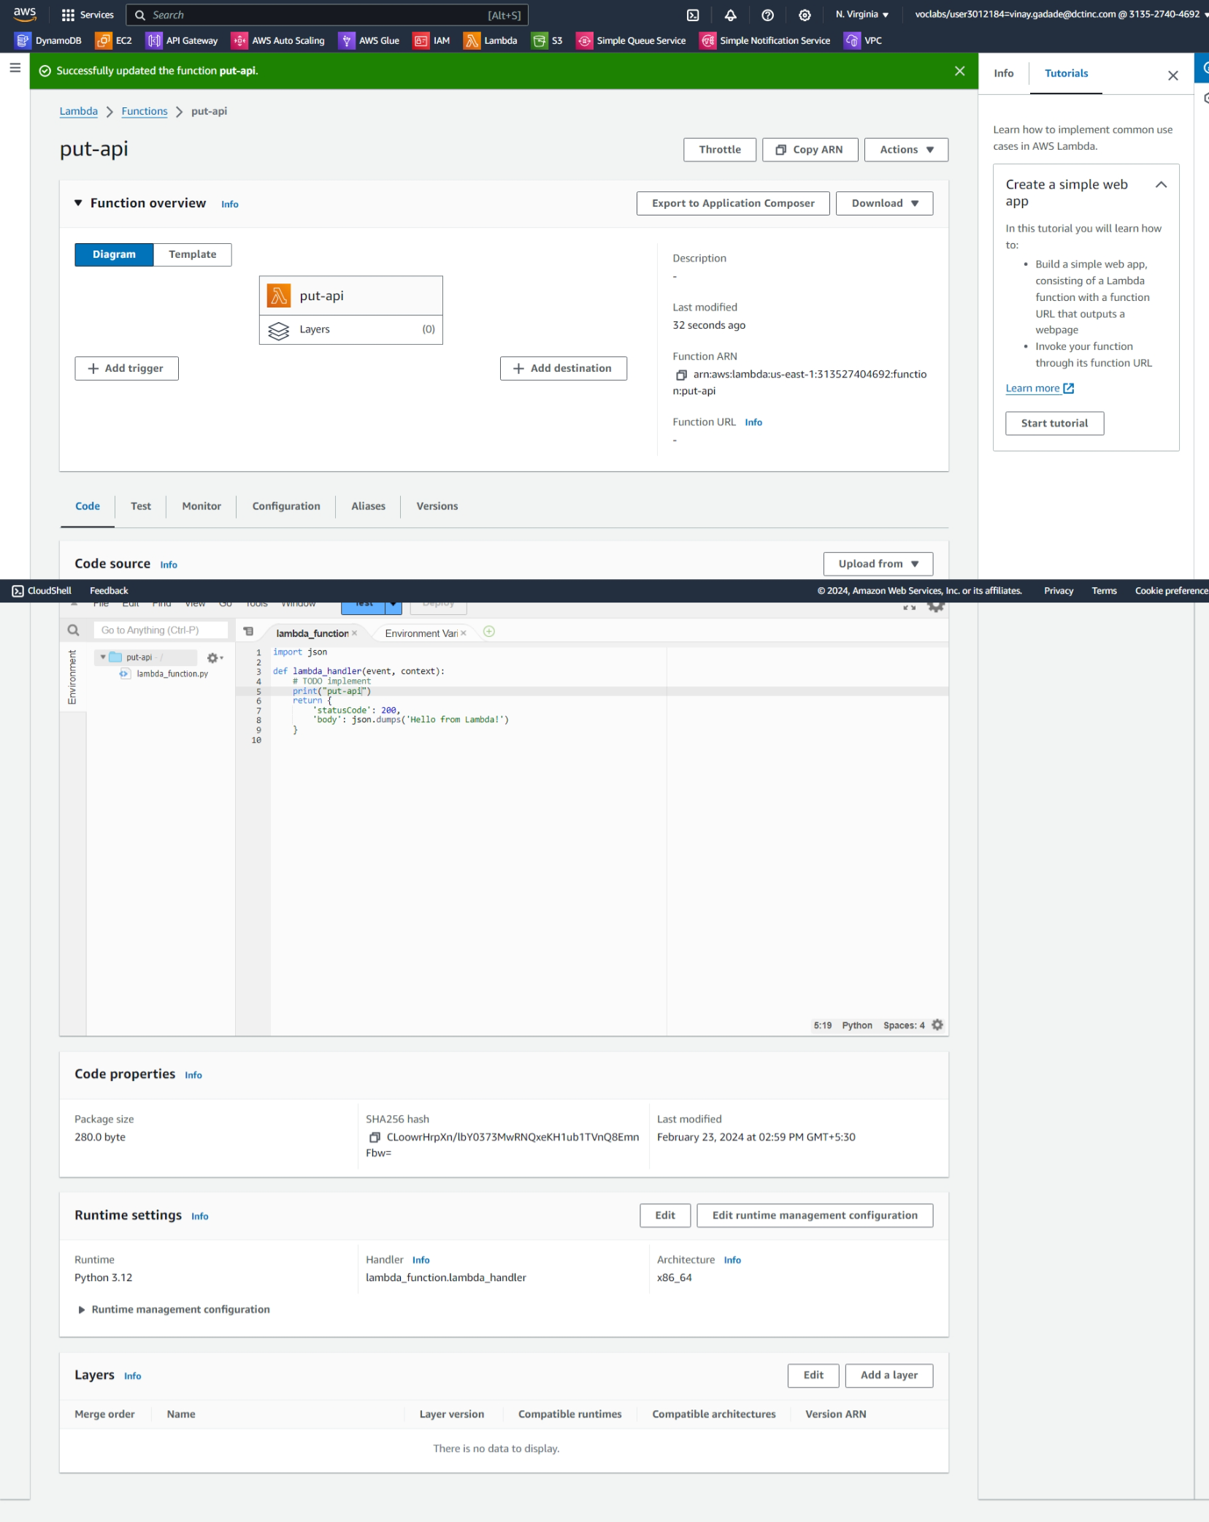

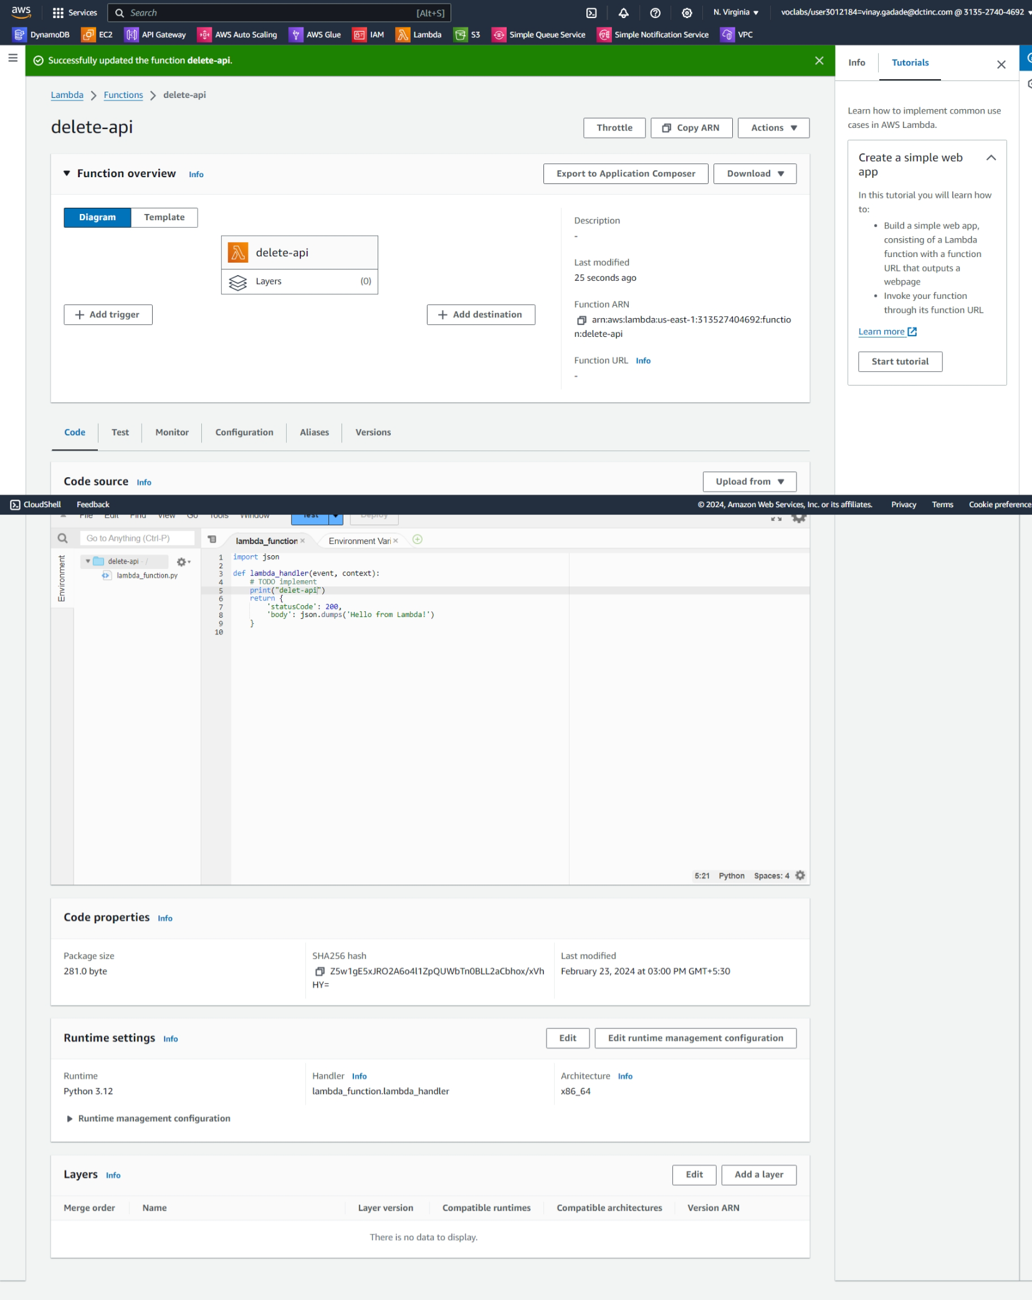

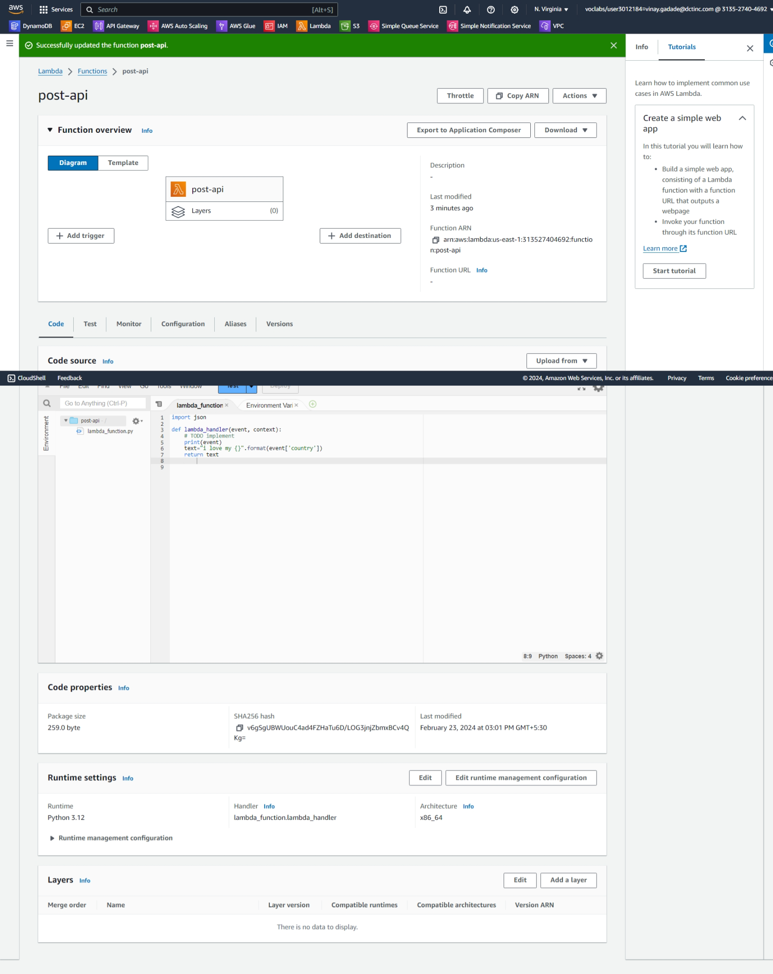

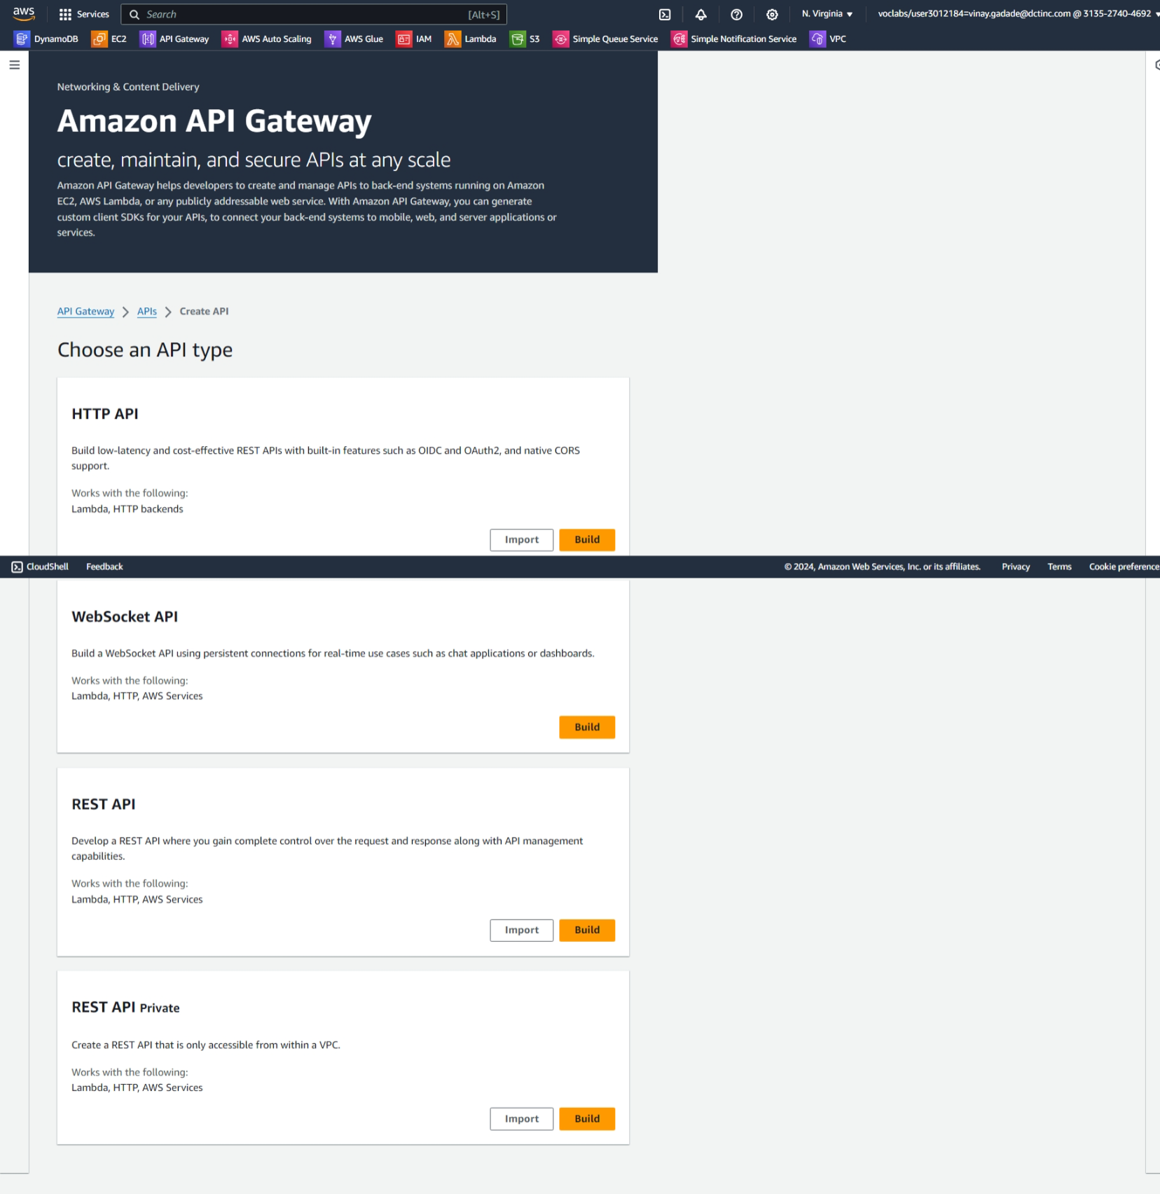

**Create 4 methods with get, post,put,delete**

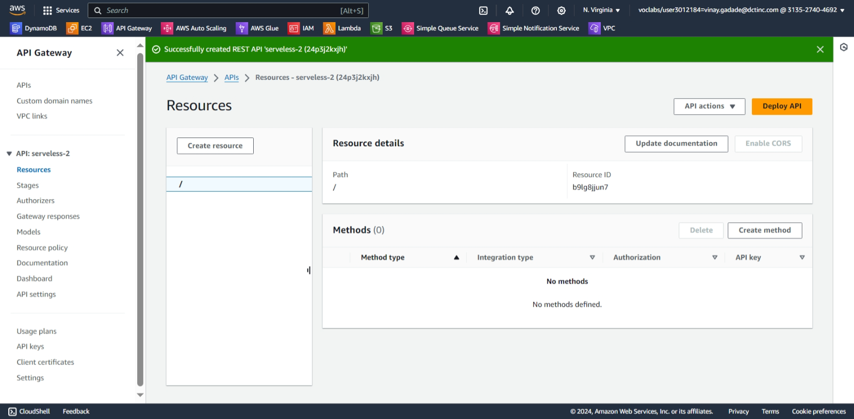

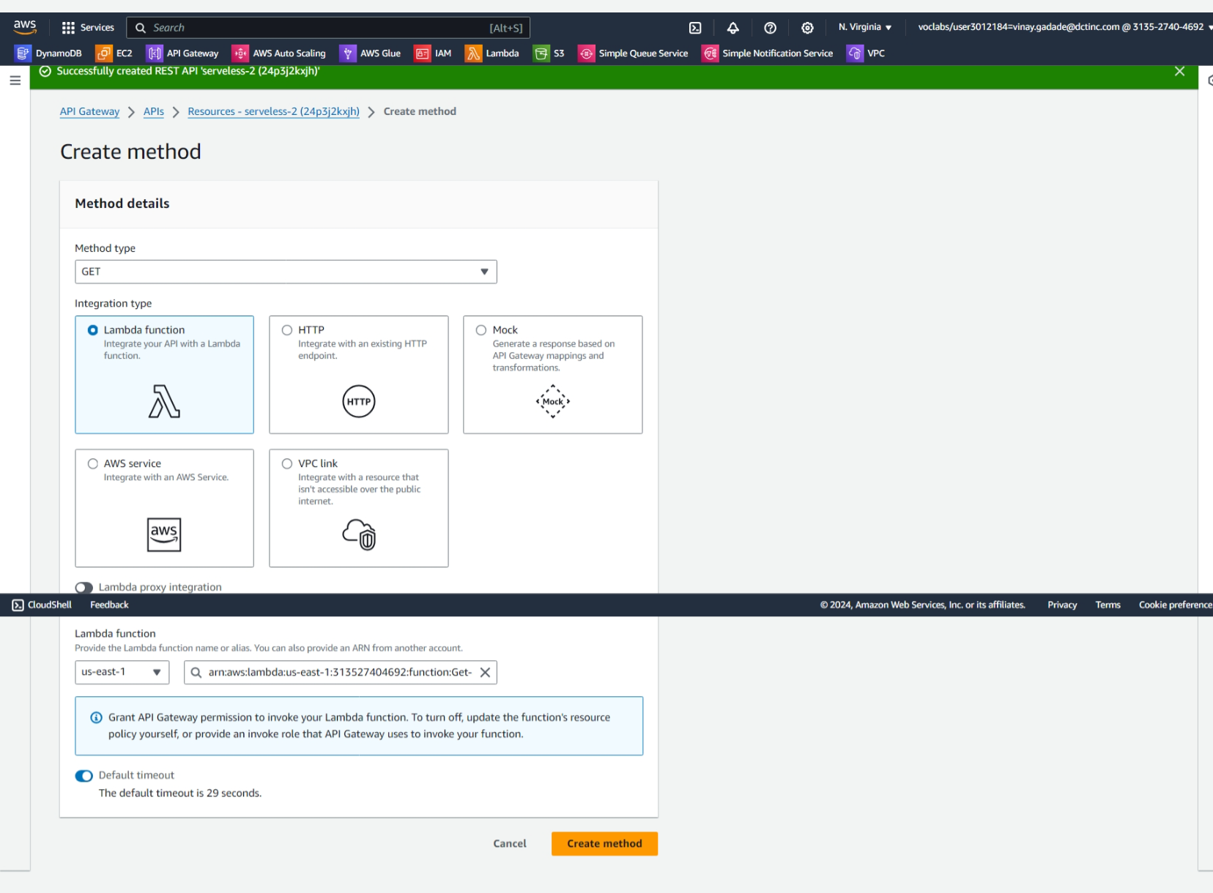

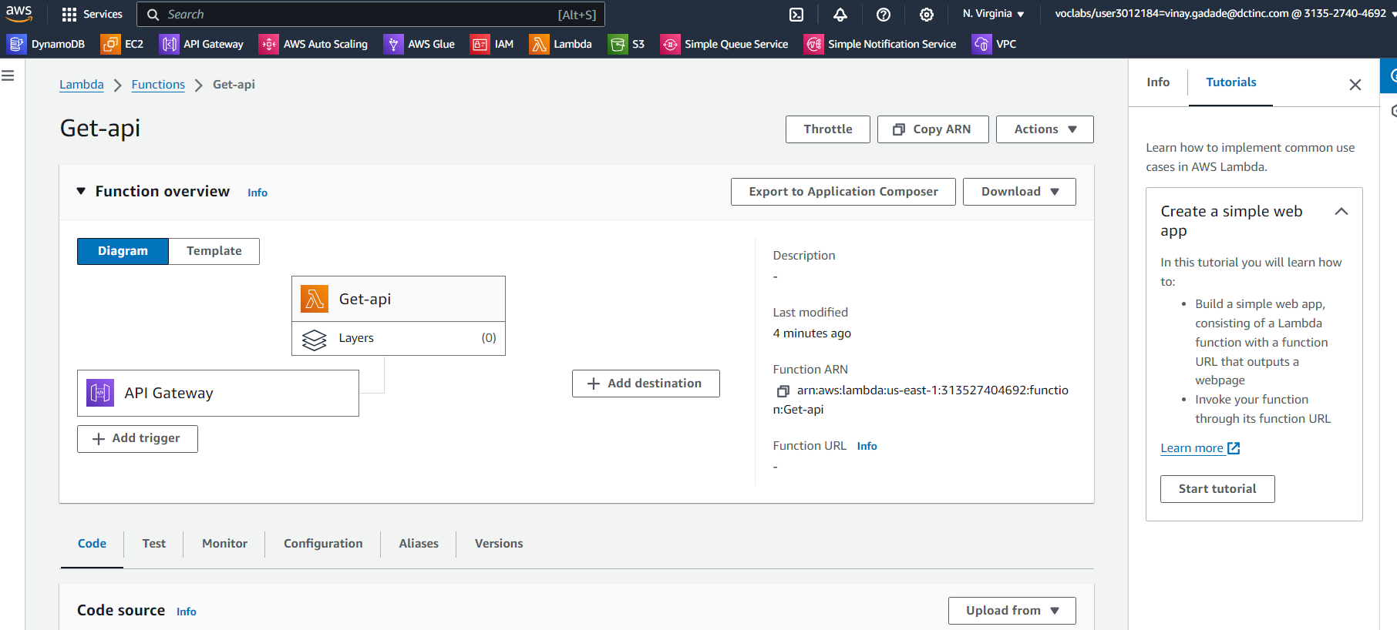

**Testing get-api do same for all api**

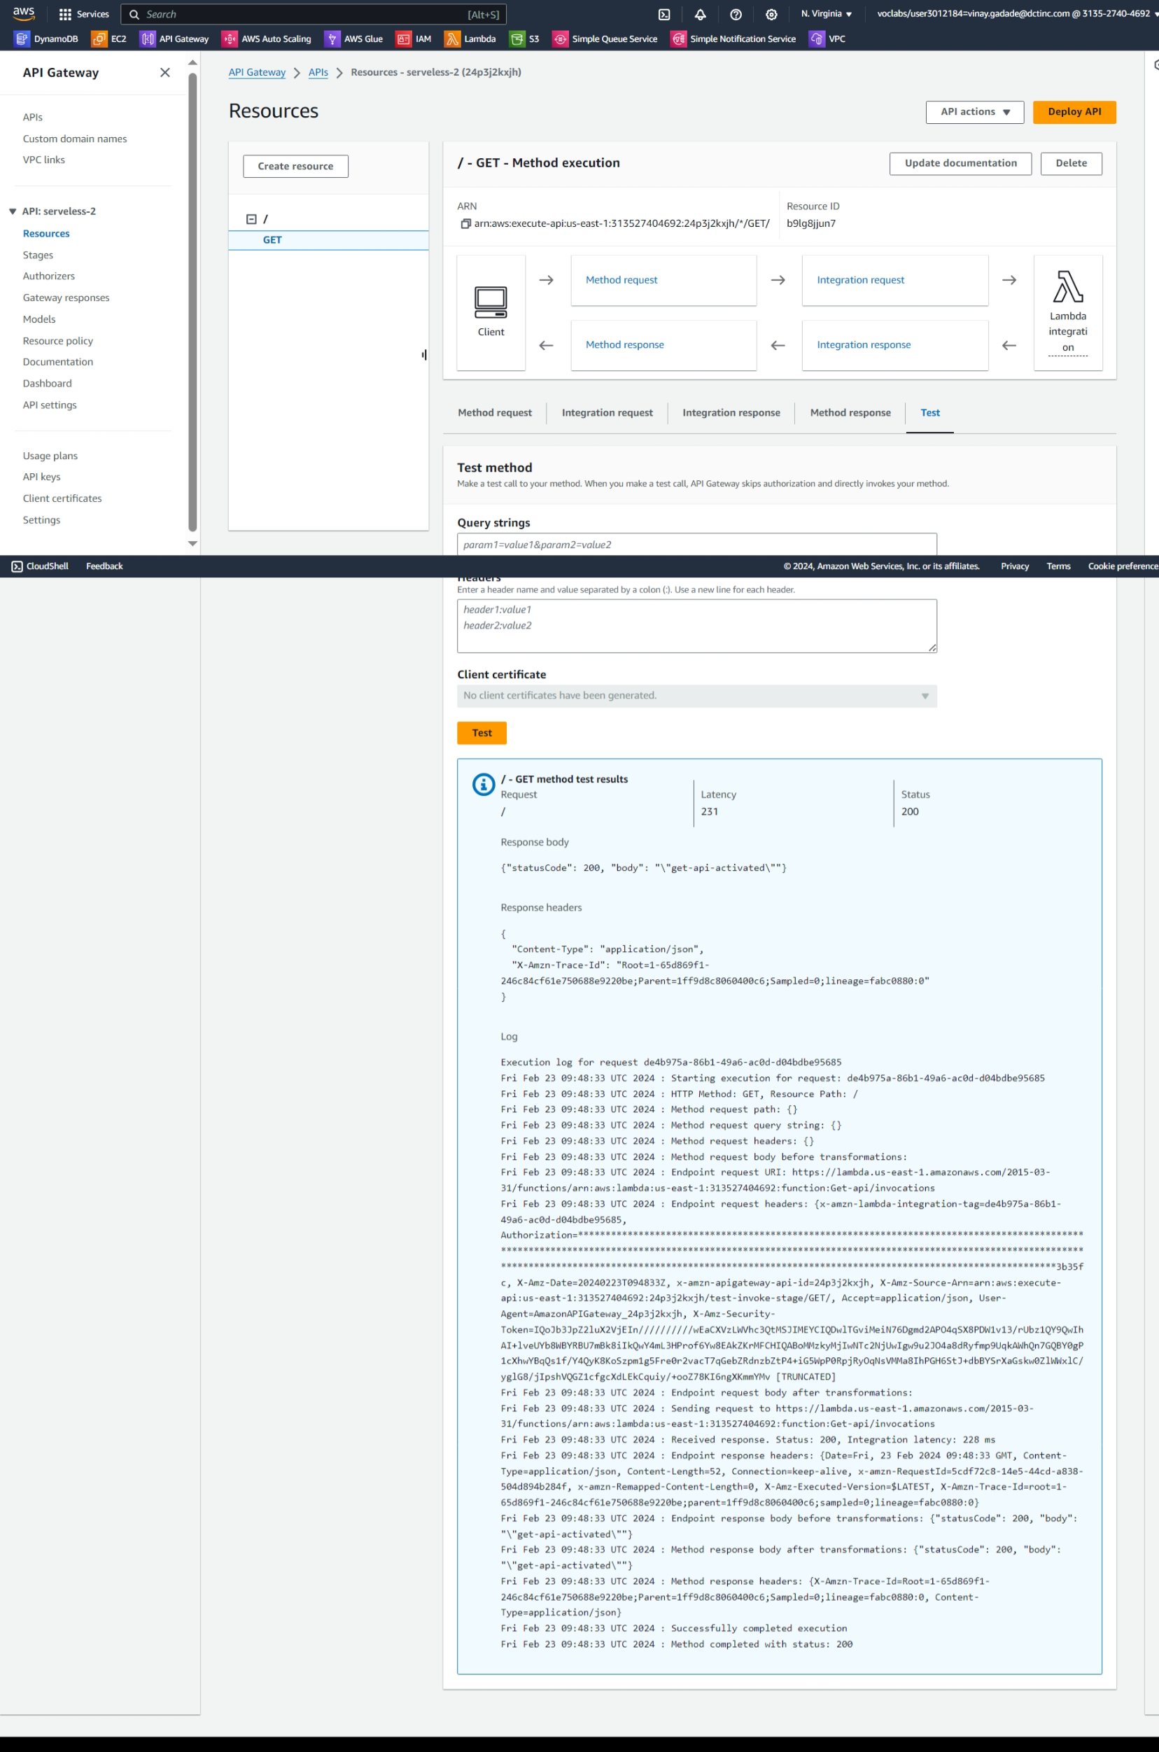



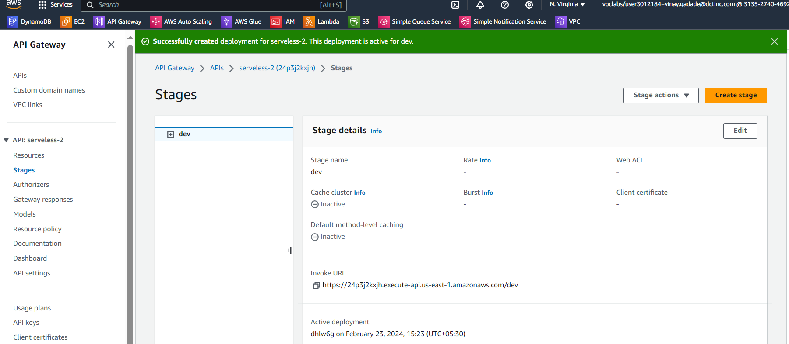

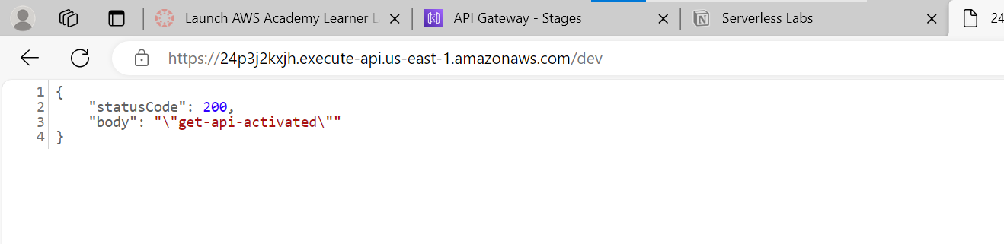

**Follow same process for all 4 functions**

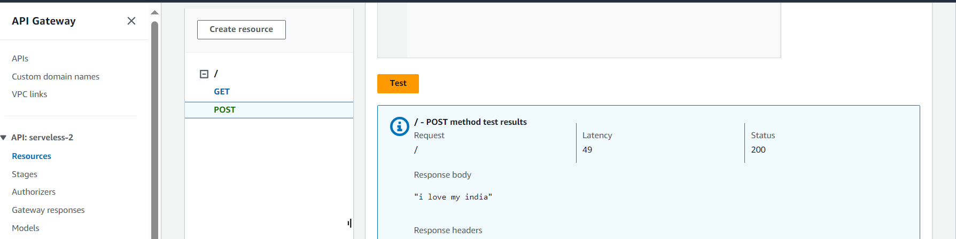

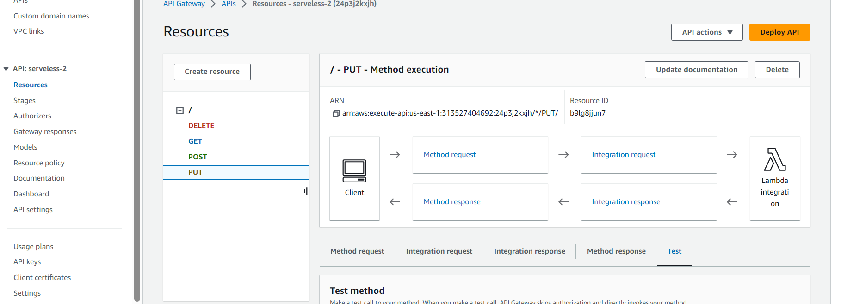

**Serverless Data Processing Pipeline**

Build a serverless pipeline for processing data (e.g., log processing or ETL jobs).

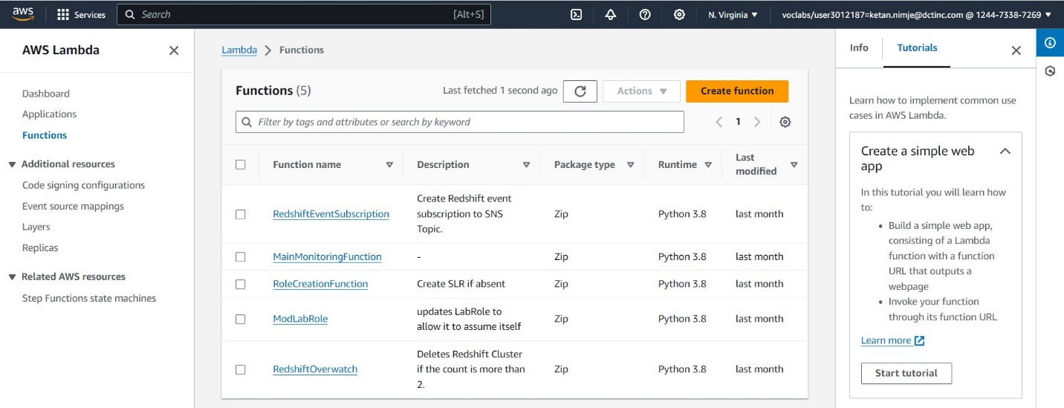

Creating a lambda function- demo lambda

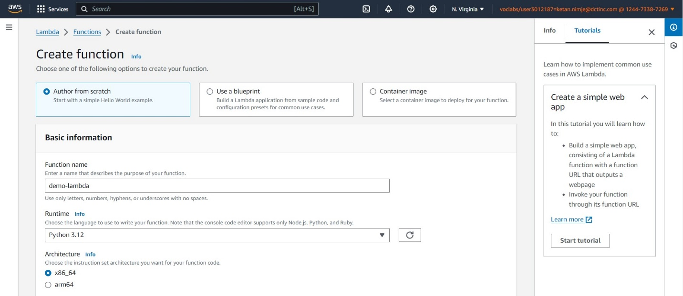

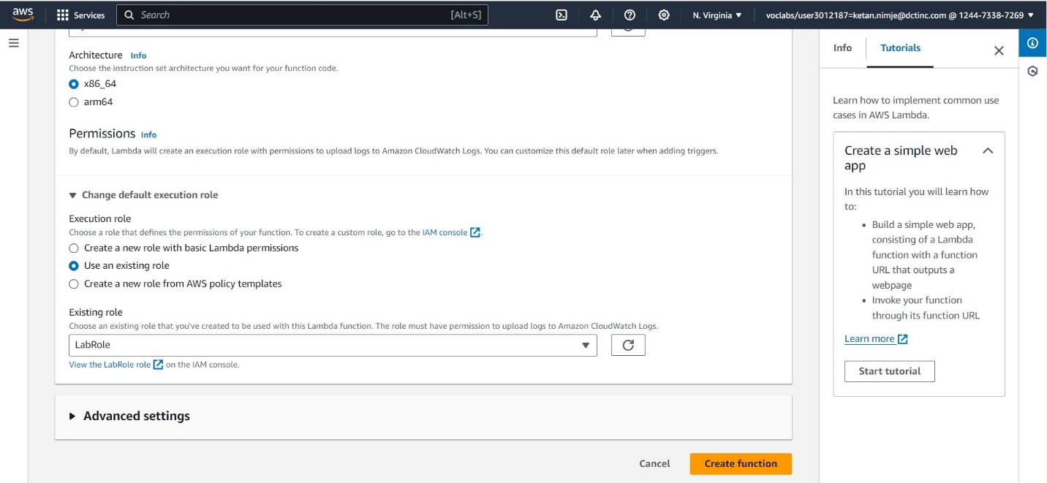

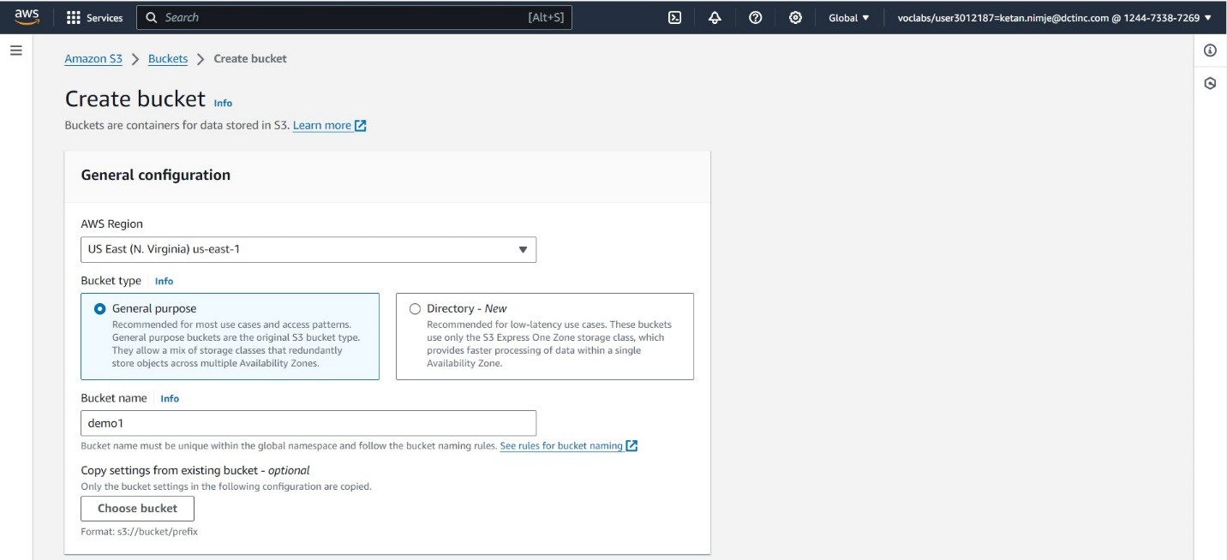

Then creating buckets for storage.

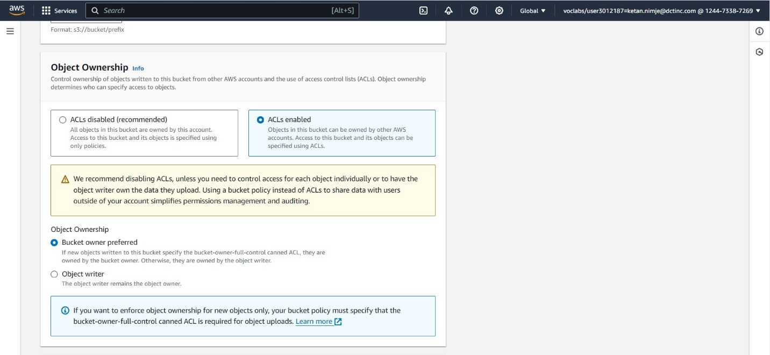

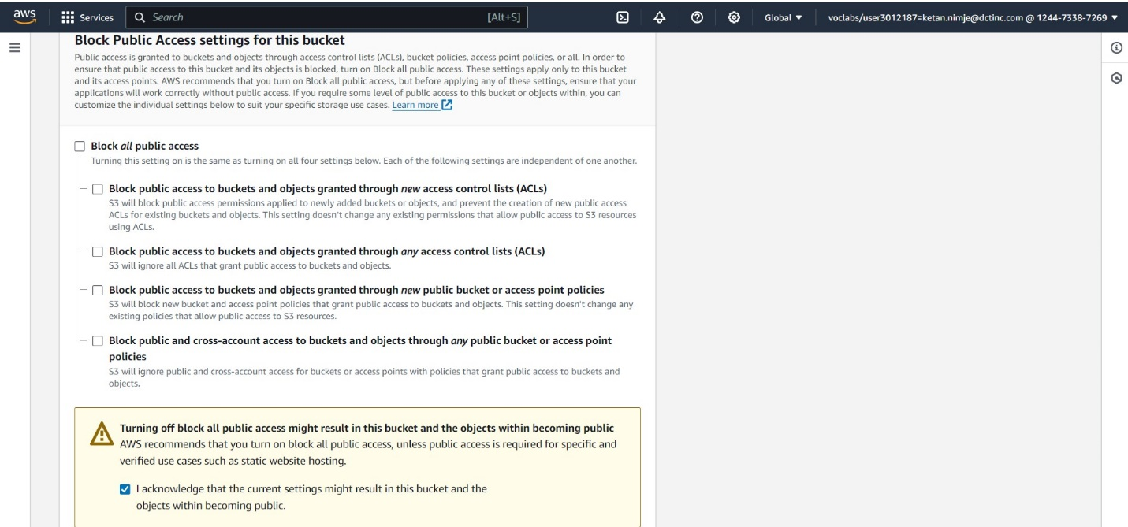

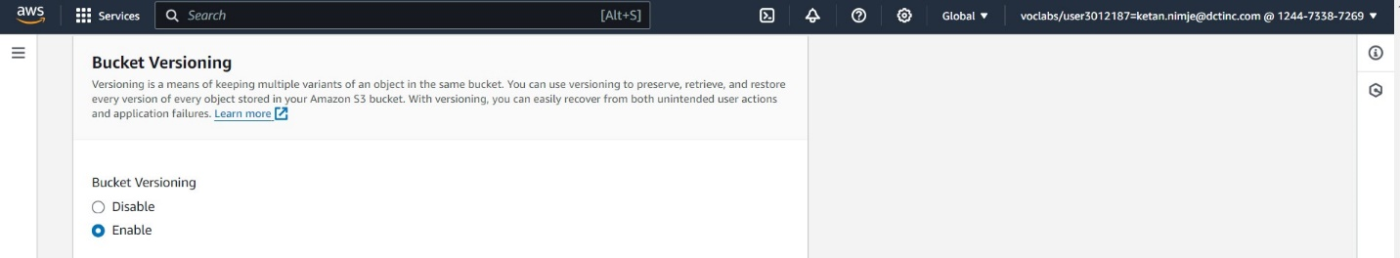

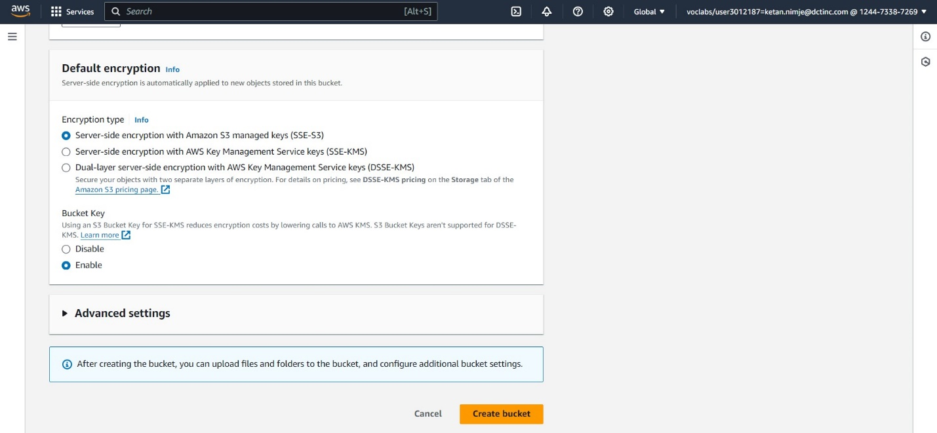

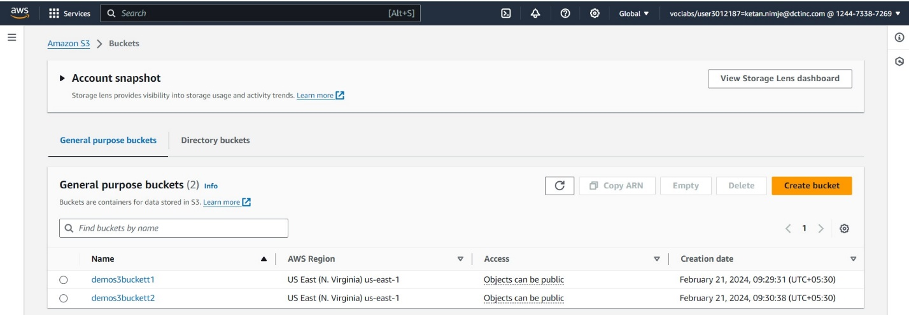

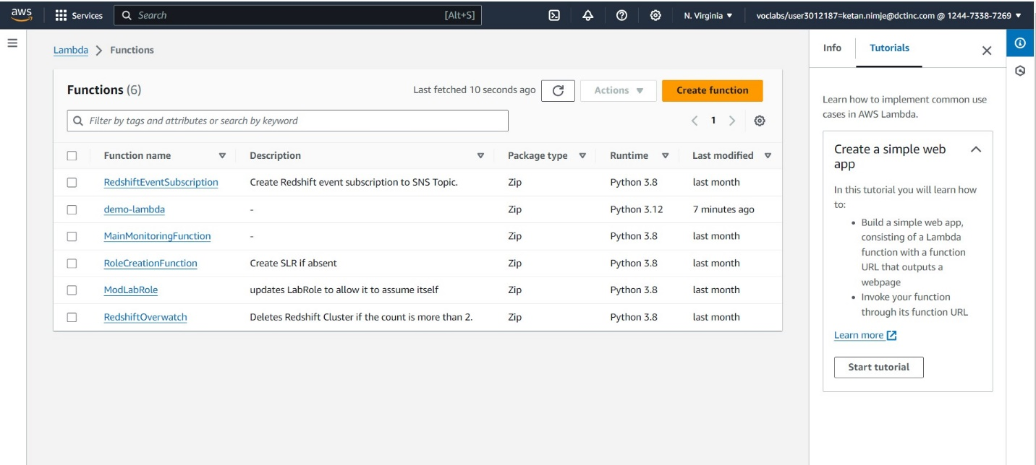

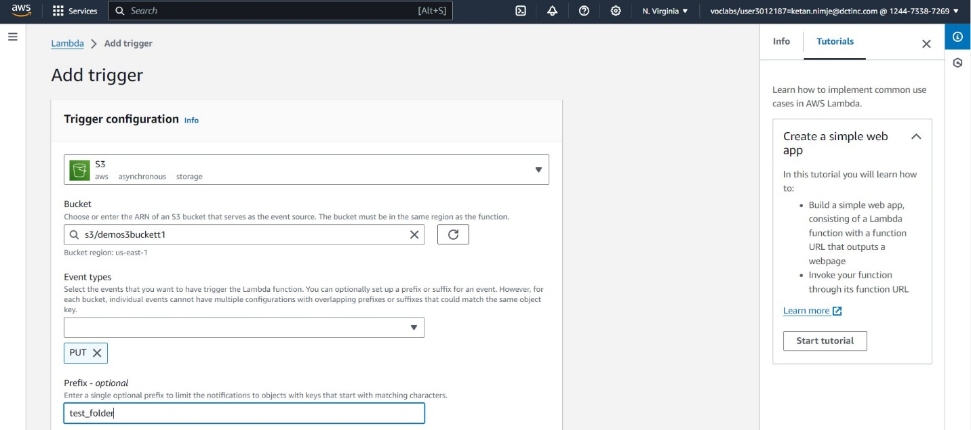

Adding S3 bucket as a trigger.

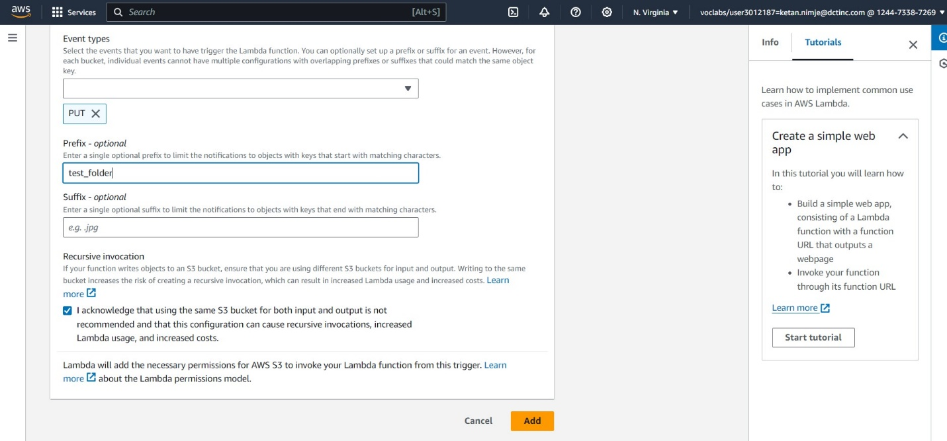

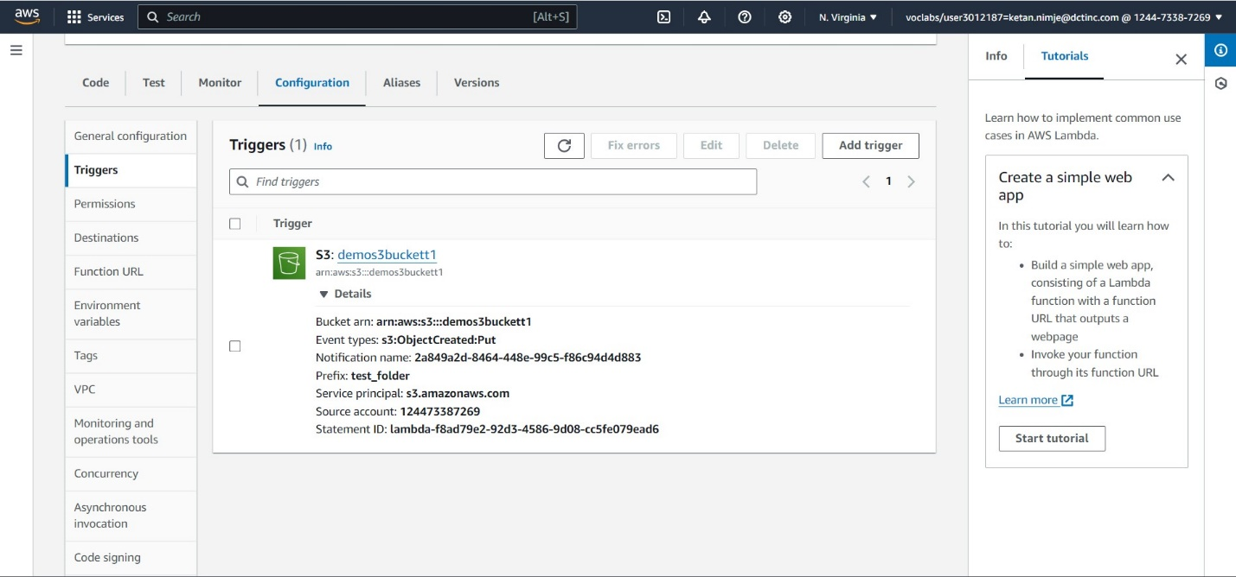

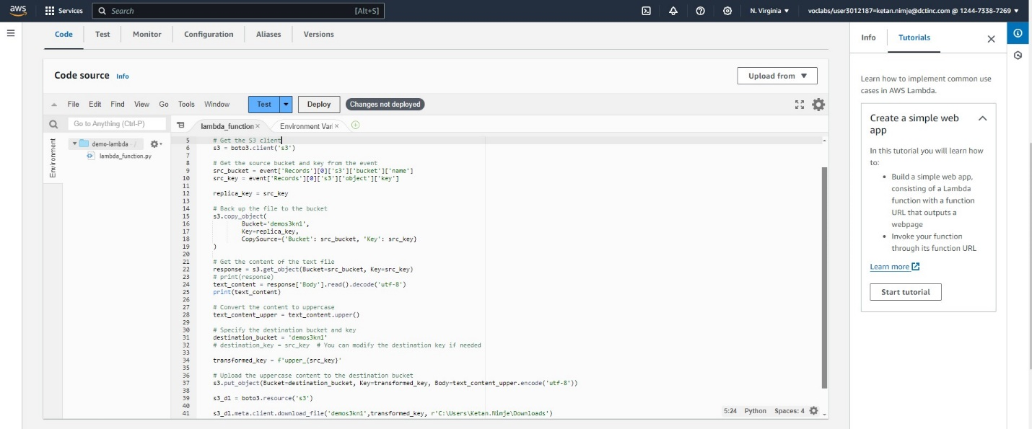

Code for triggering the lambda function when a file is uploaded into S3 bucket and then replicating the file into another bucket and creating a copy of same file in upper case in another bucket and then downloading the file into local machine.

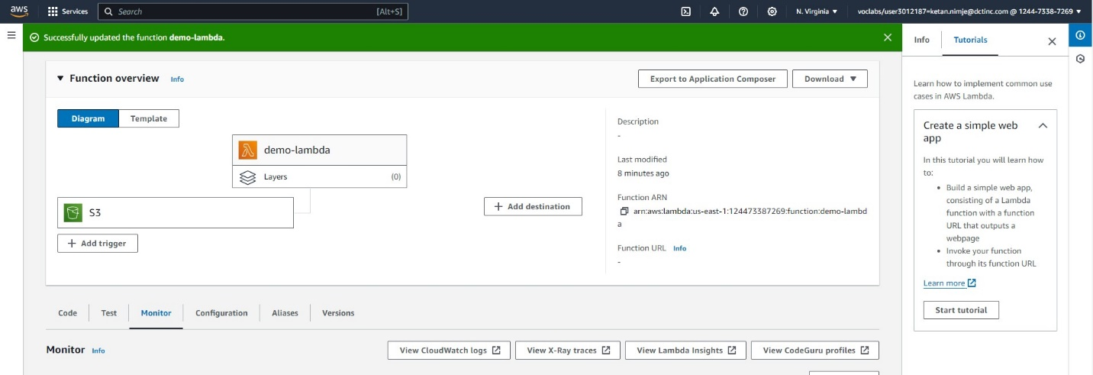

Viewing the cloud watch logs to check the status of code.

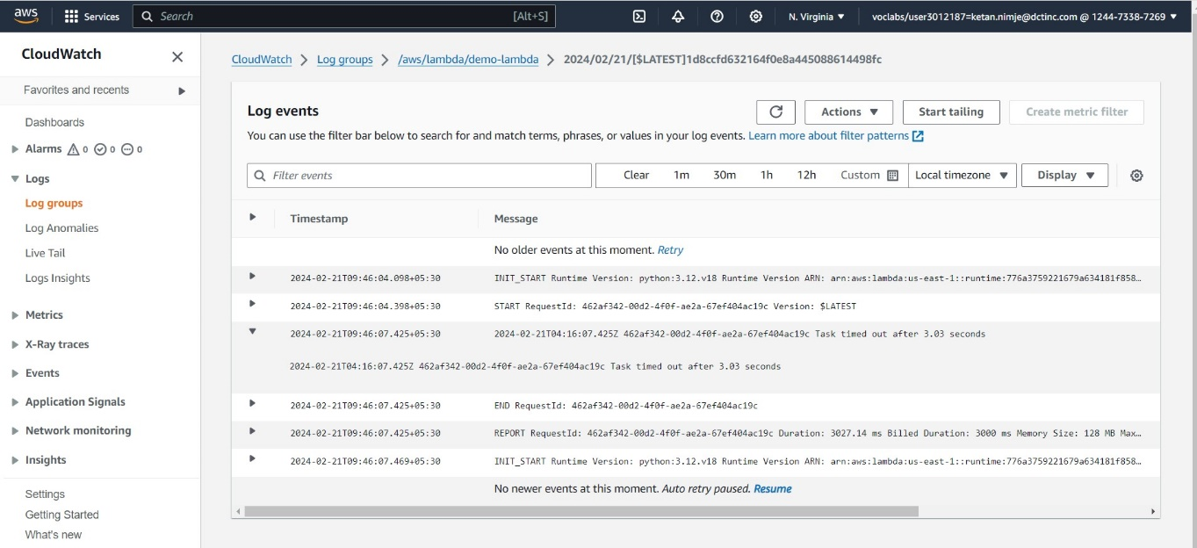

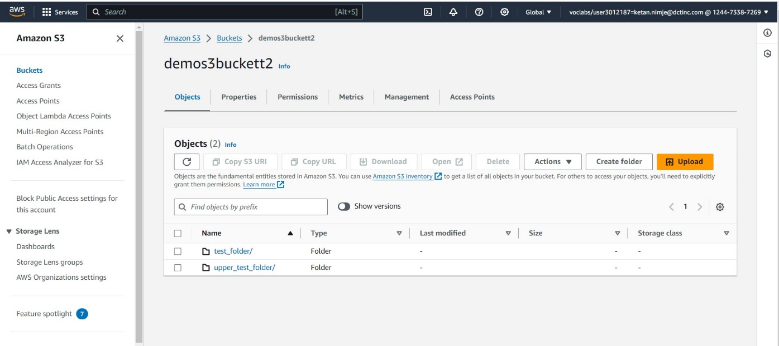

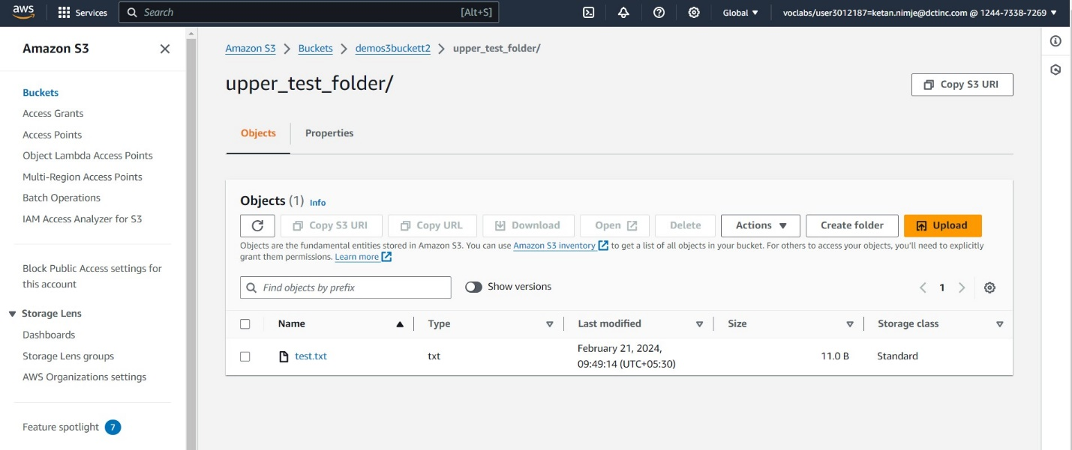

This is the desired output.